

***C# Basics***

**Lab Guides**

| **Document Code** | **25e-BM/HR/HDCV/FSOFT** |
| --- | --- |
| **Version** | **1.1** |
| **Effective Date** | **20/11/2012** |

**Hanoi, 06/2019**

**RECORD OF CHANGES**

| **No** | **Effective Date** | **Change Description** | **Reason** | **Reviewer** | **Approver** |
| --- | --- | --- | --- | --- | --- |
|  | 01/Oct/2018 | Create new | Draft |  |  |
|  | 01/Jun/2019 | Update template | Fsoft template |  |  |
| 3 | 15/Apr/2019 | Review content | Review | TuTB |  |
|  |  |  |  |  |  |
|  |  |  |  |  |  |
|  |  |  |  |  |  |
|  |  |  |  |  |  |
|  |  |  |  |  |  |
|  |  |  |  |  |  |
|  |  |  |  |  |  |

**Contents**

Lab 8: Work with Class 4

Objectives: 4

Prerequisites: 4

Problem Description: 4

Guidelines: 4

Step 1: Create project named **BookStore** in Visual Studio 4

Step 2: Add Class 4

Step 3: Create constructors 5

Step 4: Create method 6

Step 5: In Program.cs file, write code to initial objects in various ways 7

Step 6: Call GetBookInformation method for each object then check result 7

|  | **CODE: Net.S.L008**  **TYPE: SHORT**  **LOC: 50**  **DURATION: 30 MINUTES** |
| --- | --- |

# Lab 8: Work with Class

**Objectives:**

* Understand about use of Class in C#.

**Prerequisites:**

* Download and installs Visual Studio (included .net Framework)

**Problem Description:**

* Create a class in C#.
* Initial object from class in C#
* Create a class called Book to represent a book. A Book should include information:
  + - a book name,
    - an ISBN number,
    - an author name
    - a publisher
    - a published date
    - a price
* You should choose appreciate data type for each information.
* Your class should have a constructor that initializes the 3 instance variables.
* In addition, provide a method named GetBookInformation that returns the description of the book as a String (the description should include all the information about the book).
* You should use this keywor1d in member methods and constructor

**Guidelines:**

### Step 1: Create project named **BookStore** in Visual Studio

### Step 2: Add Class

Right-click on project name, choose **Add** > **Class**

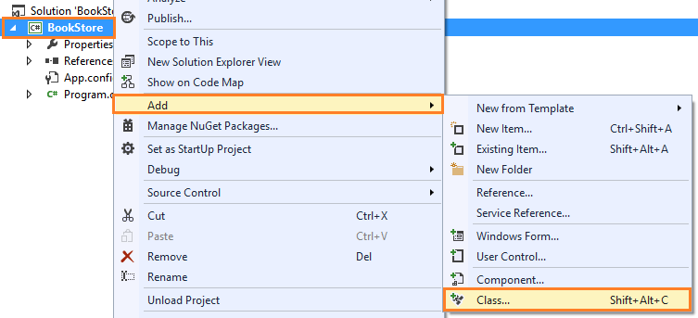

Enter class named **Book.** You can see a new file **Book.cs** is added to project. Declare Book’s properties:

namespace BookStore

{

public class Book

{

public string Name { get; set; }

public string ISBN { get; set; }

public string AuthorName { get; set; }

public string Publisher { get; set; }

public DateTime PublishedDate { get; set; }

public decimal Price { get; set; }

}

}

### Step 3: Create constructors

Create 2 constructors

/// <summary>

/// This is default contructor

/// </summary>

public Book()

{

}

/// <summary>

/// The Book's contructor to initial object with assigned values

/// In this contructor, we use this keywork to point to the current object

/// </summary>

public Book(string name, string isbn, string authorName, string publisher, DateTime publishedDate, decimal price)

{

this.Name = name;

this.ISBN = isbn;

this.AuthorName = authorName;

this.Publisher = publisher;

this.PublishedDate = publishedDate;

this.Price = price;

}

### Step 4: Create method

Create GetBookInformation method to returns the description of the book as a String

public string GetBookInformation()

{

//// Use StringBuilder to build book's information

StringBuilder bookInformatinBuilder = new StringBuilder();

//// Append each information with name and value. Each property is in one line

bookInformatinBuilder.AppendFormat("Name: {0}", this.Name);

bookInformatinBuilder.AppendLine();

bookInformatinBuilder.AppendFormat("ISBN: {0}", this.ISBN);

bookInformatinBuilder.AppendLine();

bookInformatinBuilder.AppendFormat("Author Name: {0}", this.AuthorName);

bookInformatinBuilder.AppendLine();

bookInformatinBuilder.AppendFormat("Publisher: {0}", this.Publisher);

bookInformatinBuilder.AppendLine();

bookInformatinBuilder.AppendFormat("Published Date: {0}", this.PublishedDate.ToShortDateString());

bookInformatinBuilder.AppendLine();

bookInformatinBuilder.AppendFormat("Price: {0}", this.Price.ToString("C"));

bookInformatinBuilder.AppendLine();

//// Return book's information

return bookInformatinBuilder.ToString();

}

### Step 5: In Program.cs file, write code to initial objects in various ways

//// Init book1 by use default contructor and assign value for each property

Book book1 = new Book();

book1.Name = "In Search of Lost Time";

book1.ISBN = "9971-5-0210-0";

book1.AuthorName = "Marcel Proust";

book1.Publisher = "World Scientific";

book1.PublishedDate = new DateTime(2018, 12, 07);

book1.Price = 54m;

//// Init book2 by use contructor and pass value

Book book2 = new Book(

"Don Quixote",

"9971-5-0210-0",

"Miguel de Cervantes",

"World Scientific",

new DateTime(2018, 04, 12),

30m);

//// Init book3 by use object initial

Book book3 = new Book()

{

Name = "Hamlet",

ISBN = "9971-5-0210-0",

AuthorName = "William Shakespeare",

Publisher = "World Scientific",

PublishedDate = new DateTime(2018, 12, 07),

Price = 98m

};

### Step 6: Call GetBookInformation method for each object then check result

Console.WriteLine("===== Book store management! =====");

Console.WriteLine("==================================");

Console.WriteLine(book1.GetBookInformation());

Console.WriteLine(book2.GetBookInformation());

Console.WriteLine(book3.GetBookInformation());

Console.ReadKey();

**Outputs**

